Project Overview
Render link: https://habittracker-assignment03.onrender.com
The Habit Tracker Web Application is a simple productivity tool that helps users build positive habits by recording their daily progress. The goal of the application is to allow users to add habits, track their completion over time, edit or update habit information, and delete habits they no longer want to maintain.

This is a CRUD-based (Create, Read, Update, Delete) system built using Node.js, Express.js, MongoDB, Mongoose, and EJS views, following the MVC pattern.
The purpose of the project is to help users improve consistency and visualize their progress on habits such as:
Drinking water
Exercising
Reading
Sleep schedule
Healthy eating
Meditation

This application creates an easy way for users to stay motivated by keeping their daily activities organized.

2. Learning Objectives & Why This App Makes Sense
This application demonstrates:
Understanding of Express routing
Creating Mongoose model
Performing CRUD operations
Using EJS templates and Bootstrap component
Organizing code using proper project structure
Connecting to MongoDB Atlas securely using .env
Deploying to Render / Azure
Following good programming practices (comments, folders, partials)

The Habit Tracker idea is simple, realistic, and fits perfectly into the required grading rubric.

3. Key Features of the Application
1. Add Habit (Create)
Users can create new habits by entering:
Habit name
Description
Frequency (daily/weekly)
Notes
Stored in MongoDB.
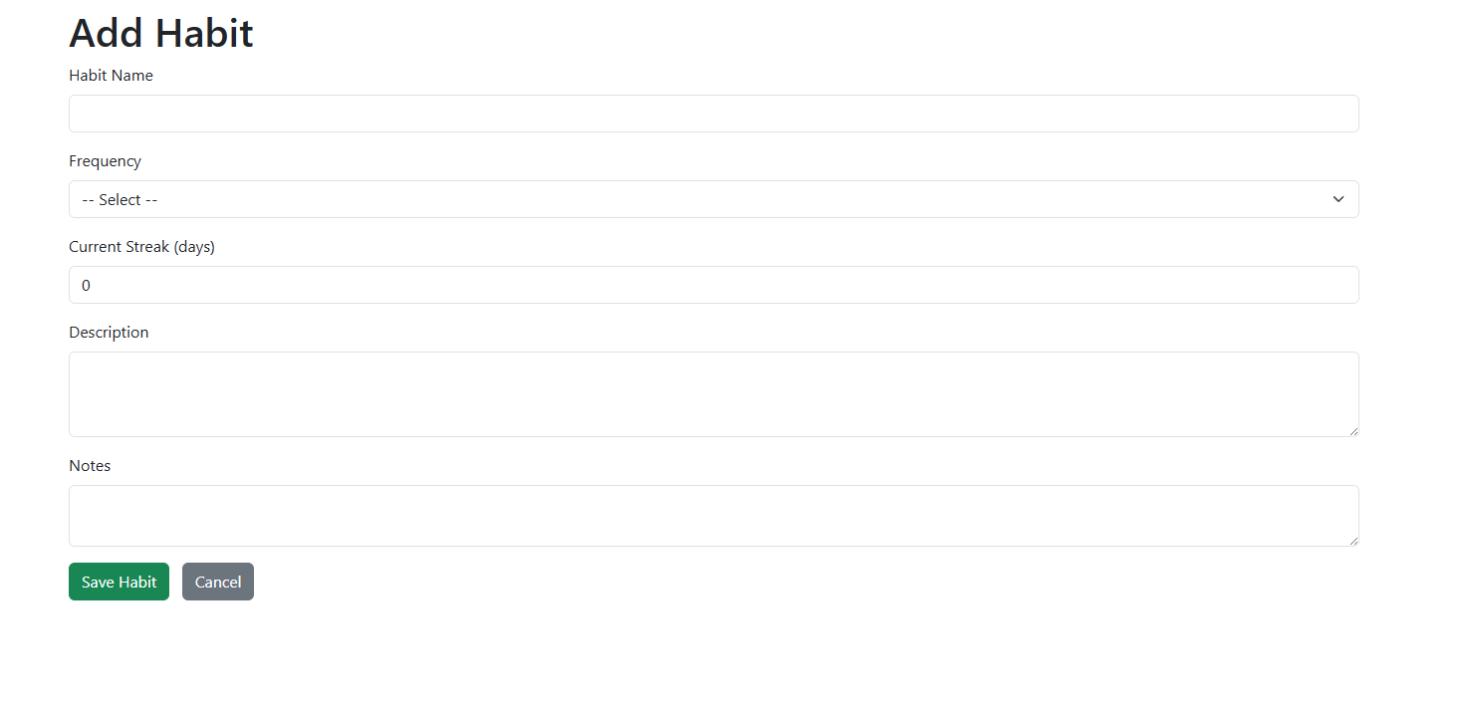

2. View All Habits (Read)
A table displays all habits using an EJS template:
Habit name
Frequency
Progress or streak
Options (Edit / Delete)
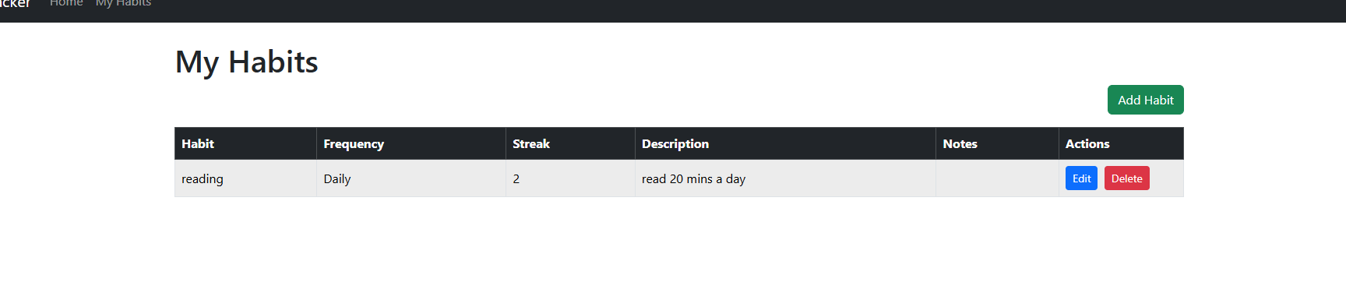

3. Edit Habit (Update)
Users can update:
Name
Description
Frequency
Daily streak
Notes

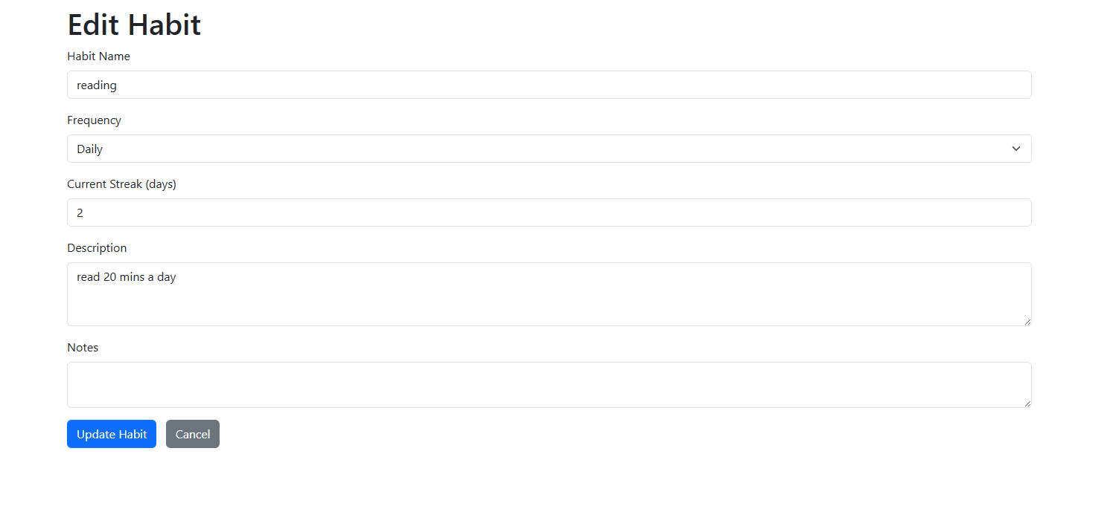
4. Delete Habit with Confirmation (Delete)
A confirmation page ensures accidental deletion does not occur.
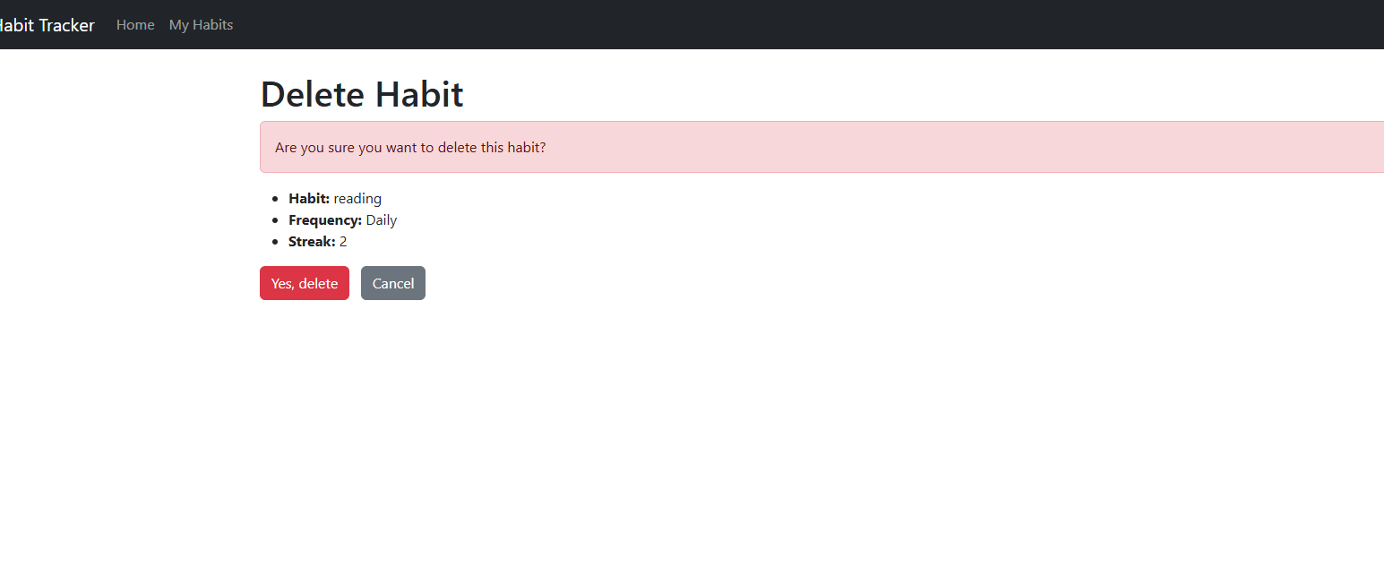

5. Home Page (Splash Screen)
The home page communicates the purpose of the app with:
Inspirational image
Description
“Start Tracking” button
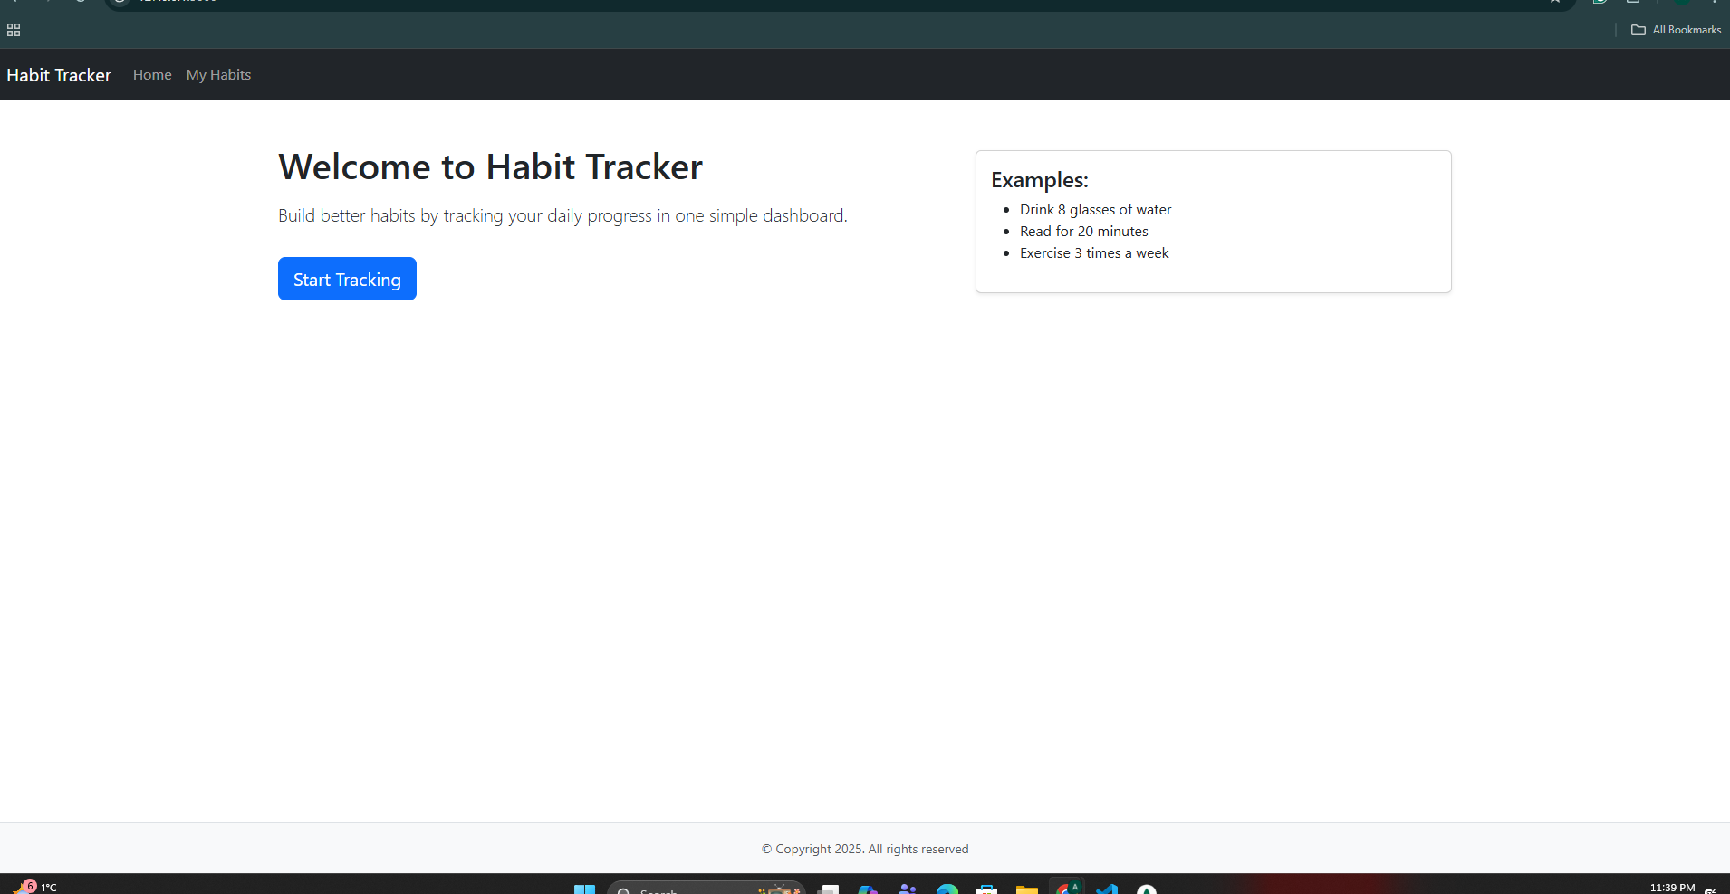

🔹 6. Responsive Layout
Uses Bootstrap to ensure the application looks clean on desktop and mobile.

